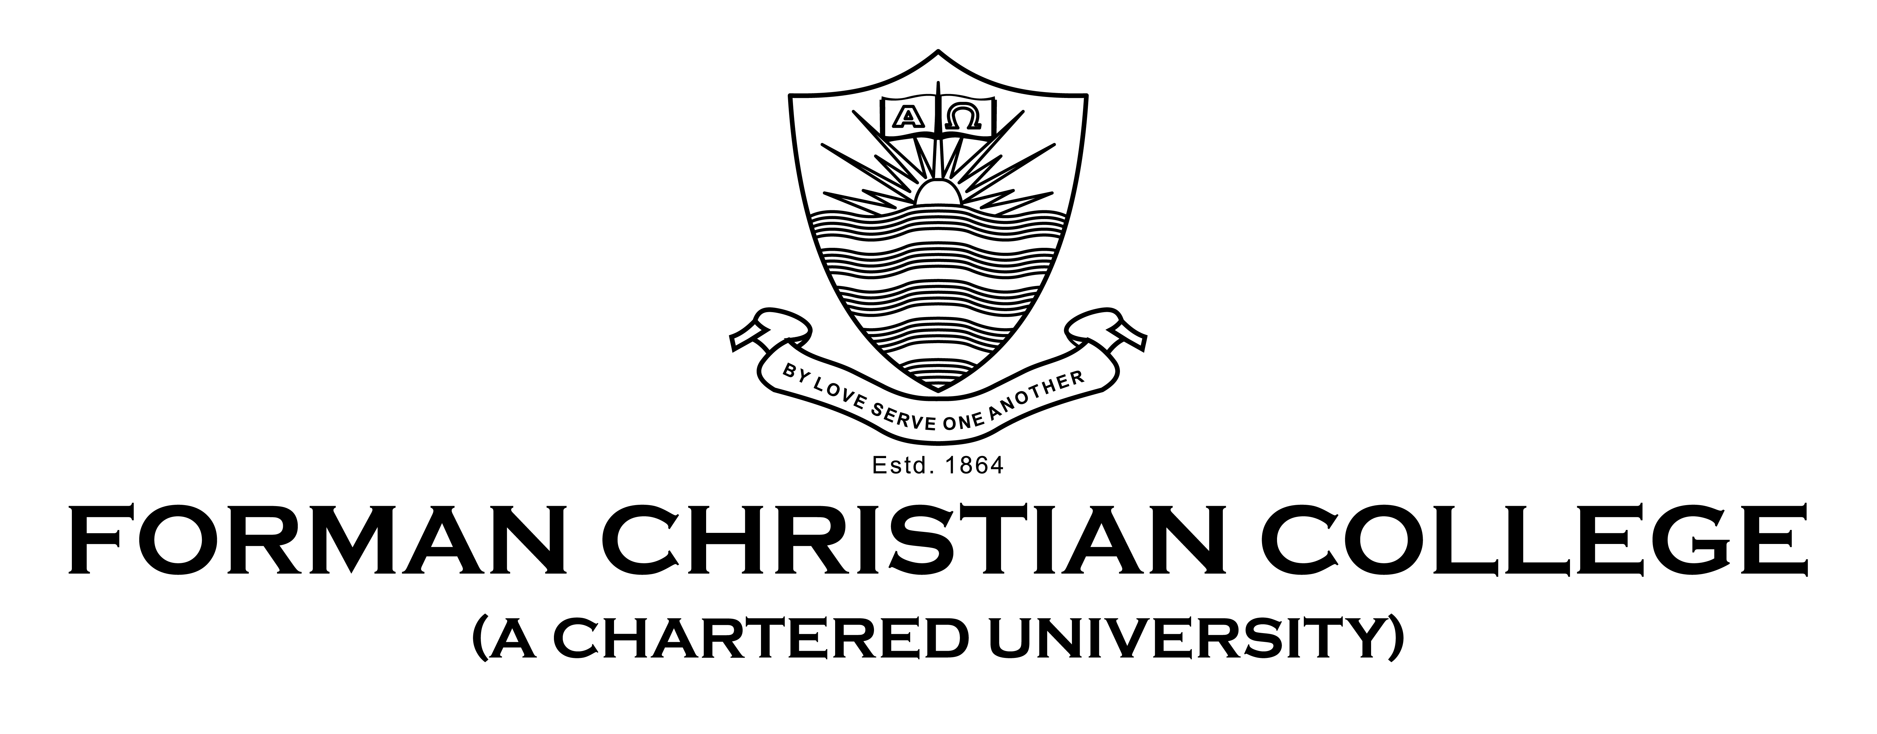

**Name**: Abdul Ahad Butt

**Roll**: 231-485930

**Course**: Software Quality Assurance

**Section**: A

**Submitted to**: Saad Bin Saleem

**Result Screenshots**

Selenium was installed with python in the visual studio code and testing was done on Chrome Browser. Both correct and wrong credentials were provided in the code and checked. These were the following results for the tests conducted:

1. **Result with correct credentials**

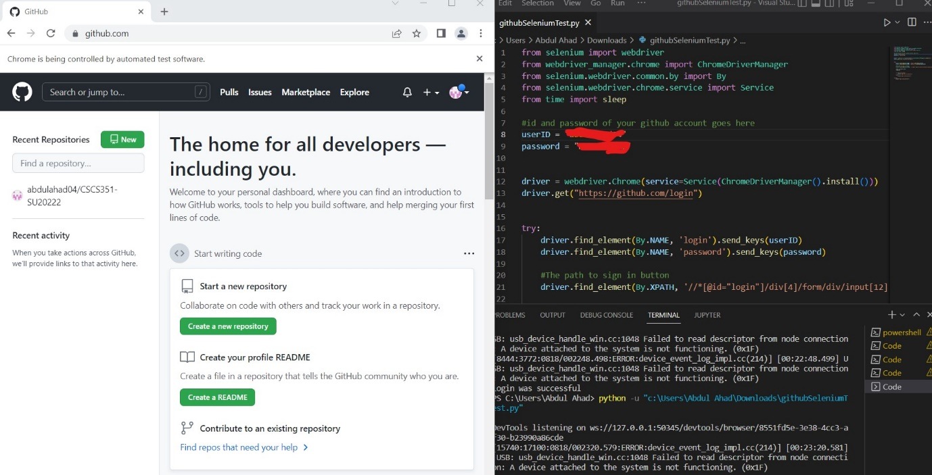

1. **Result with wrong credentials**

